**Using custom html widget in Wordpress to make small area of text editable**

**1.** Within this footer we need to use a custom html widget to on the left and right of the footer to allow the client to edit information.

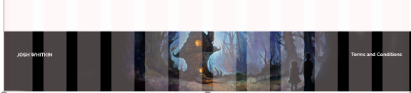

This is the name that appears in the widgets

**2.** Lets make our client name an editable text area.

In functions.php we need to first register a widgetised area

We will wrap the widget in a DIV

<?php

function footer_left() {

  register_sidebar( array(

    'name'          => 'footer-left',

    'id'            => 'footer-l',

    'before_widget' => '<div>',

    'after_widget'  => '</div>',

The name of our function as above

  ) );

}

add_action( 'widgets_init', 'footer_left' );

?>

**3.** Go to footer.php and add the reference to the footer-left widget

 <footer class="container-fluid text-center"><!-- div for the main image to stretch s to the edge of the page-->

                <div class="container"><!-- div to hold the content in the middle of the page-->

                    <div class="row"><!-- a row that gives us access to the BS columns-->

                        <div class="col-md-6 widgetleft">

                          <?php if ( !function_exists('dynamic_sidebar') || !dynamic_sidebar('footer-left') ) :

endif; ?>

                        </div>

                        <div class="col-md-6 ">

                            <p>Terms and Conditions</p>

              </div><!-- row-->

                    </div><!-- container -->

                </div><!-- container-fluid-->

            </footer>

            <?php wp_footer(); ?>

</body>

</html>

**4.** Upload functions.php and footer.php

**5.** Got to the Wordpress dashboard>Appearance>Widgets

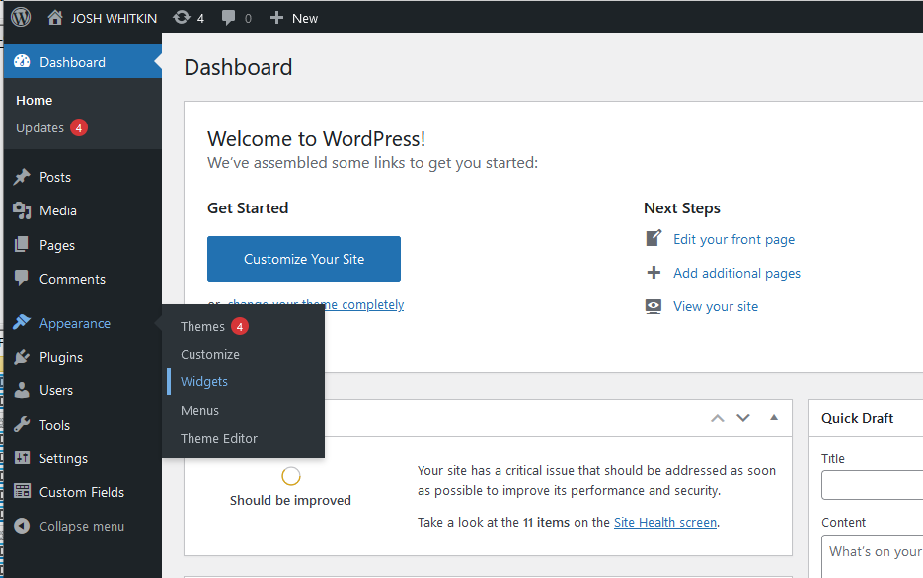

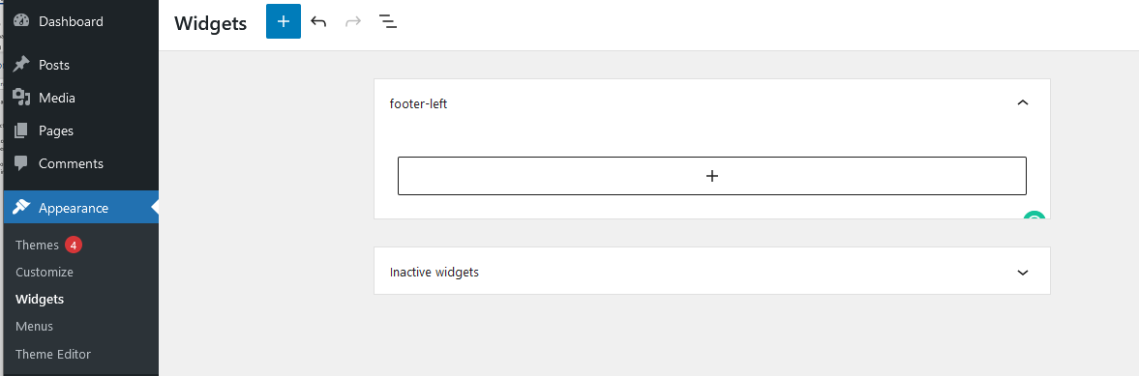

**6.** Click on the Plus button and find in the Widgets area click on the custom HTML block

**7.** Go to the header.php and find the navbar brand class and copy that into the Custom HTML

a class="navbar-brand" href="#"><span class="josh">JOSH</span> <span class="orange">WHITKIN</span> </a>

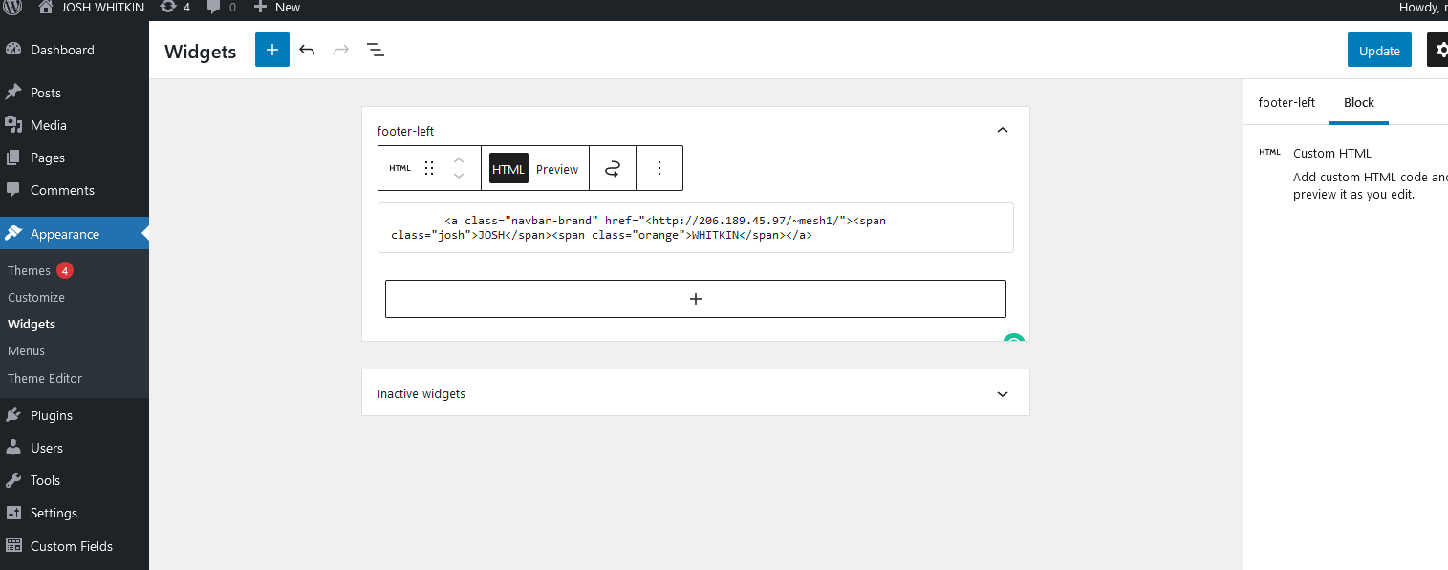

Go to the home page and refresh in the browser



Now we can do the right side

**8.** Go back to functions.php and add a footer_right function

<?php

function footer_right() {

  register_sidebar( array(

    'name'          => 'footer-right',

    'id'            => 'footer-r',

    'before_widget' => '<div>',

    'after_widget'  => '</div>',

  ) );

}

add_action( 'widgets_init', 'footer_right' );

?>

**9.** Go to Footer.php and add the reference to footer_right widget

               <footer class="container-fluid text-center"><!-- div for the main image to stretch s to the edge of the page-->

                <div class="container"><!-- div to hold the content in the middle of the page-->

                    <div class="row"><!-- a row that gives us access to the BS columns-->

                        <div class="col-md-6 widgetleft">

                          <?php if ( !function_exists('dynamic_sidebar') || !dynamic_sidebar('footer-left') ) :

endif; ?>

                        </div>

                        <div class="col-md-6 ">

                        <?php if ( !function_exists('dynamic_sidebar') || !dynamic_sidebar('footer-right') ) :

endif; ?>

              </div><!-- row-->

                    </div><!-- container -->

                </div><!-- container-fluid-->

            </footer>

            <?php wp_footer(); ?>

</body>

</html>

**10.** Upload to Josh’s theme

**11.** Open The Wp Dashboard/ Appearance/ Widgets and a paragraph to the right-footer widget

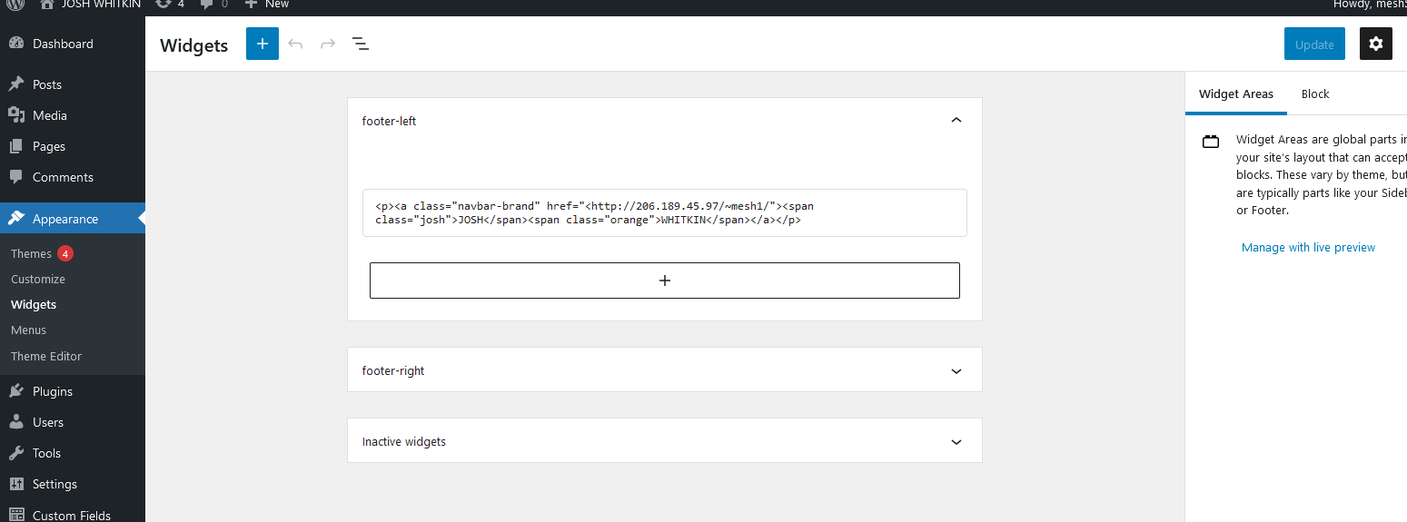

**12.** Update the page

Reload the browser



**Create a favicon for our website**

**1.** You will notice that our site does not have a favicon

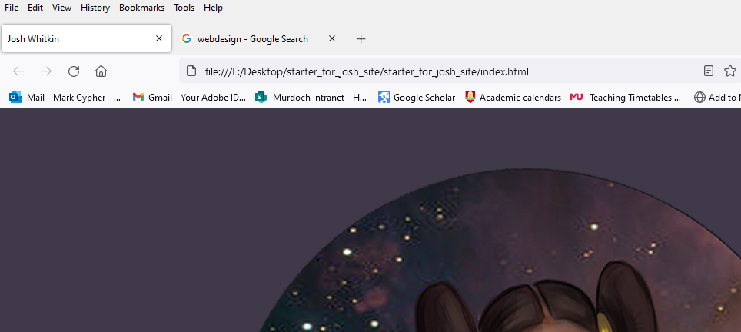

????

Google Favicon

**2.** Favicons help for SEO, brand awareness and favicons appear next to bookmarks  
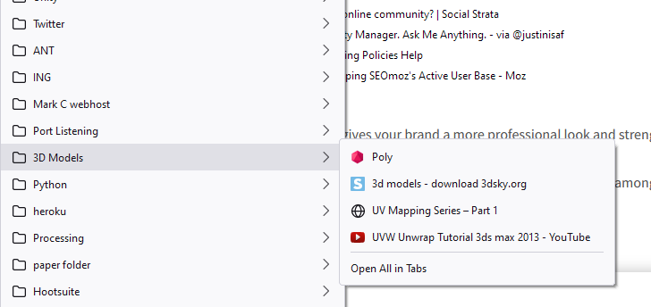

**3.** Open Figma and make a 64 X64 frame- Export the image as a PNG  
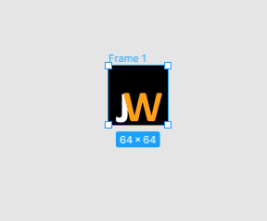

**4.** Go to <http://faviconer.com/> or any number of free ICO generators on the web

Import/Upload your PNG

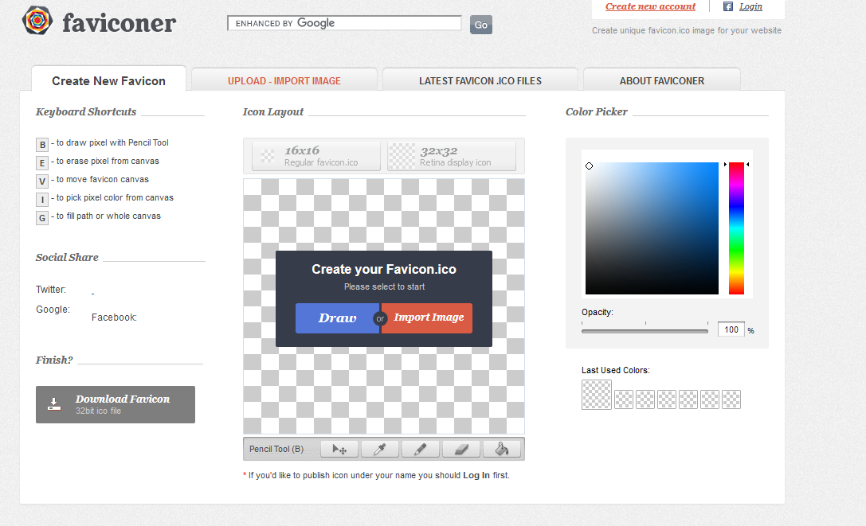

**5.** Download the favicon.ico into your images folder

**6.** Add this line into the head of INDEX.HTML just after the meta tages

<link rel="icon" type="image/x-icon" href="images/favicon.ico" />

You should have something like this

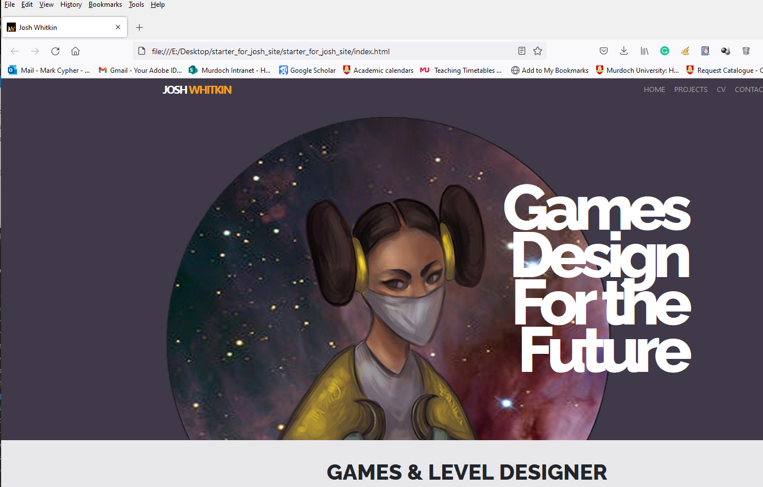

**7.** To get this on the live site you will need to make sure that all the header.php files have the right URL

<link rel="shortcut icon" href="<?php bloginfo('template_directory'); ?>/images/favicon.ico">

**8.** Then upload the all the header.php, small-header.php and page-header.php files into Josh’s theme and then upload the favicon.ico into the images folder

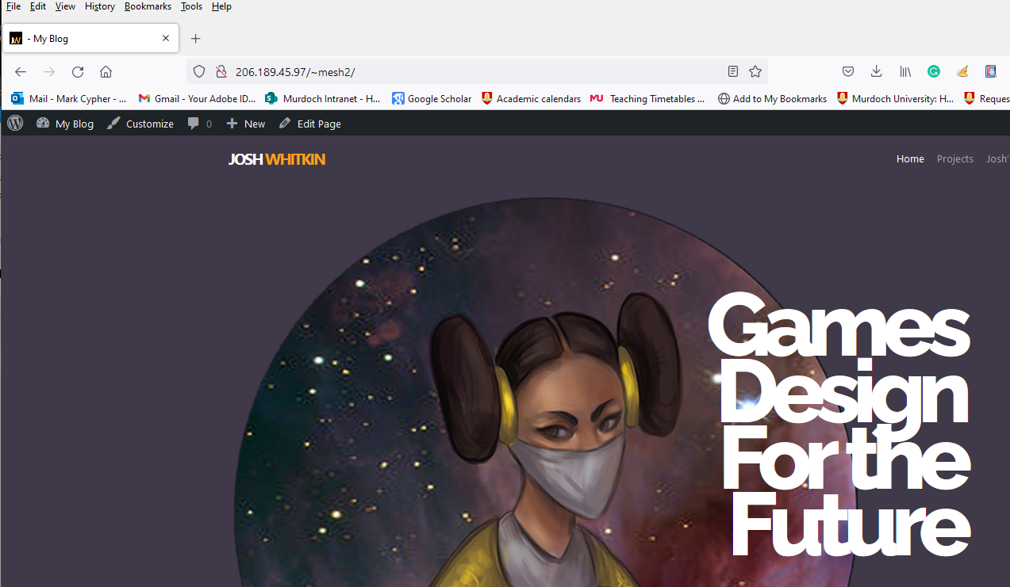

**9.** Make sure to Commit and Push to Origin the new files